**ArcGIS ModelBuilder and some useful workflows for hydrocarbon exploration**

#arcgis #arctoolbox #oilandgas #exploration #explorationandproduction #hydrocarbon #geology

ModelBuilder in ArcGIS is a visual programming tool for building geoprocessing workflows. It can be used for a complex workflow with several intermediate steps, or to automate repetitive jobs using any combination of tools from the ArcToolbox. You create and modify geoprocessing models in ModelBuilder, where a model is represented as a diagram that chains together sequences of processes and geoprocessing tools, using the output of one process as the input to another process. Any tool in the ArcToolbox can be used to create a model, which then can be run from the ModelBuilder window itself or can be made into a custom tool within ArcToolbox. ModelBuilder can even be used to integrate ArcGIS with other applications. The models can be shared with other users a tools for extending ArcGIS functionality.

Excellent introduction to ModelBuilder is available from the following websites.

<https://desktop.arcgis.com/en/arcmap/latest/analyze/modelbuilder/what-is-modelbuilder.htm>

<https://desktop.arcgis.com/en/arcmap/latest/analyze/modelbuilder/creating-tool-with-modelbuilder-tutorial.htm>

**Creating a basic workflow to interpolate point data and contour the resultant grid**

This model takes a point dataset (point shape file or event file), and interpolates it using a mask polygon, and then contours it. The process is simple for a single file, but for more than a couple files this becomes tedious. This repetitive process can very well be automated using model builder. We can even run this process in a loop for all the point files in a mxd.

The model starts with an input point data file (Blue oval), runs an interpolation tool (Yellow rectangle) on it to produce an intermediate grid file (Green oval). It then takes an input mask polygon, and the intermediate grid file as input for an Extract by Mask tool and gives a final output raster. It takes this output raster as input for the contour tool and output the contours. The “P” in the inputs or tools are the parameters that can be input when the model is run as a tool from a toolbox

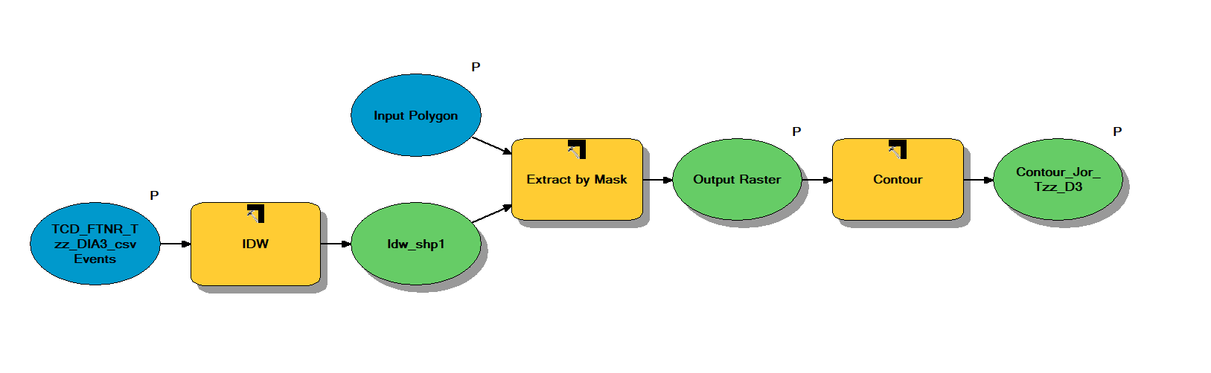

Figure . Model for creating a contoured grid file

**Finding structural closures using ArcGIS ModelBuilder**

This model can be used to quickly find structural closures in a DEM grid file, which can be very useful in early stage exploration. The model starts with a grid file, multiples it by -1 using the Negate tool (if this is not done, it will find the structural lows instead), use the Fill tool to fill the sinks (negative of the highs), and then subtract the negative grid file from the filled negative grid file using the Minus tool to isolate the sinks only. Then the model inverts it again using the Negate tool to get back the highs, contour it using the Contour tool, and displays it. A hillshade grid is generated using the Hillshade tool either from the original DEM or the isolated highs grid for better visualization.

As a next step, the model can be enhanced by extracting each largest closed contour, and calculate area/ volume for each closure, but that would require at least an ArcEditor license.

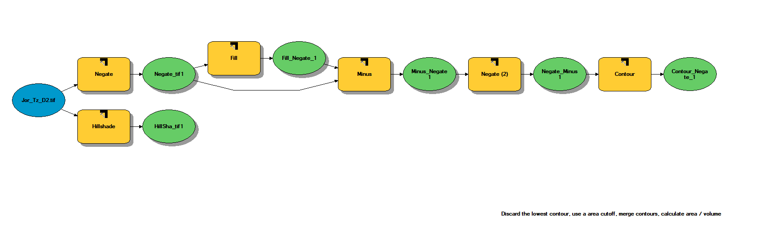

Figure . Model for finding structural highs in a DEM

**Creating hydrocarbon migration pathways using ArcGIS ModelBuilder**

A very common task in hydrocarbon exploration is understanding the upward migration pathway of oil or gas from a source kitchen. The following model creates a drainage network of hydrocarbon flows from a fetch area, and mostly uses tools from the hydrology toolset in ArcToolbox. It creates a drainage network on an inverted surface to mimic upward hydrocarbon flow. The same workflow without inverting the starting raster can be used to create fluvial drainage network over any surface. It looks complex, so let’s break up it into smaller segments.

The model starts with a raster surface along which the upward hydrocarbon migration needs to checked. The surface is inverted using the Negate tool, and then smoothened using the Fill tool. A Fill Z limit parameter is used in the Fill tool to control the amount of smoothening. Typically, a value of 100 is used to fill the inverted surface grid.

In the next step, the Flow Direction tool is used to calculate the direction of fluid flow for each raster cell, which is then used as input to the Flow Accumulation tool, together with a raster for the fetch area. If the inverted grid is directly used for the fetch area (instead of a small area extracted by mask using a fetch polygon), each cell will act as a source for fluid flow. The Flow Accumulation tool calculates the amount of fluid ultimately collecting into each cell, starting with an initial value of 1 for each cell, and increasing it by the cell value it receives from the adjacent 8 cells according to the flow direction surface. The Raster Calculator tool is then used to extract those cells having an accumulation in excess of a cutoff value (typically between 1 to 100), and the Stream Order tool is used to assign a sequential ordering to the extracted grid cells. These are then converted to polylines using the Stream to Feature tool, with the polylines being assigned the same value as that of the grid cell being converted. This gives us the stream order polyline, which can be displayed using proportional symbols to visually show the stream order. The output is normally displayed over the original non-inverted surface to show the upward migration of hydrocarbon from a kitchen area (shown as blue shaded area in the figure).

The output surface from the Flow Direction tool is also used to create a watershed polygon map, by using the Basin tool and converting the resultant raster grid to polygon using Raster to Polygon tool.

This workflow produces a quick check migration model a user-defined fetch area, which can be used to upgrade a lead as part of the exploration workflow. It can also be used to create a fluvial drainage network if the starting grid is not inverted, which can be useful in creating conceptual GDEs in regions with less available data. The model can be run directly from the ModelBuilder editor, or the inputs can be used as parameters, and it can be run as any other tool from ArcToolbox.

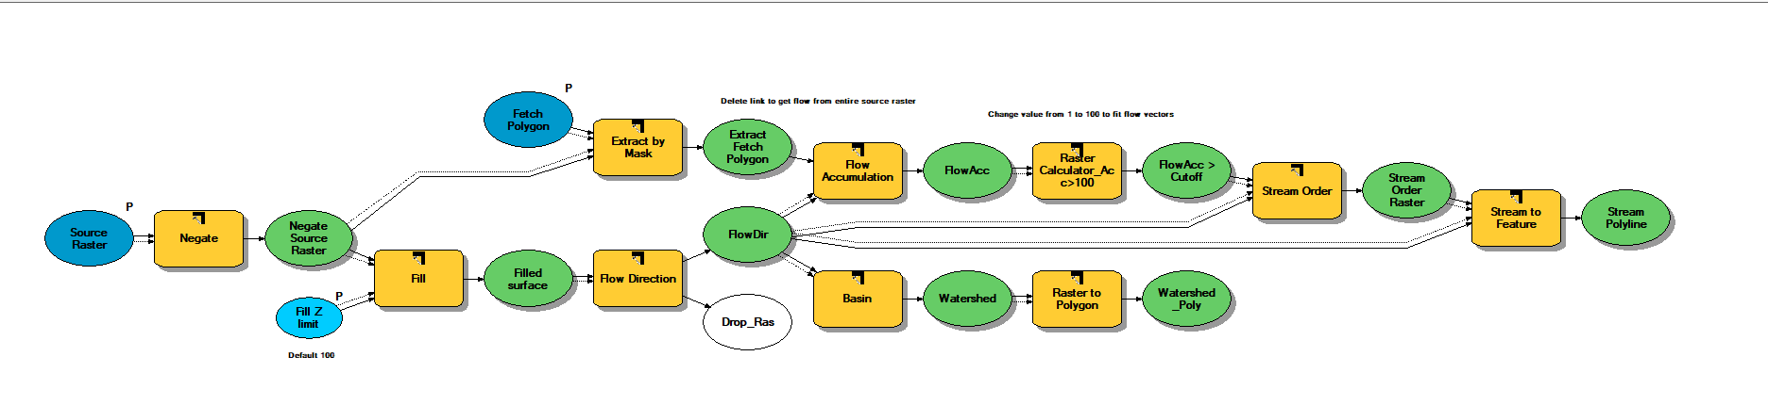

Figure . Model for creating a hydrocarbon migration pathway from a fetch area, together with watershed delineation

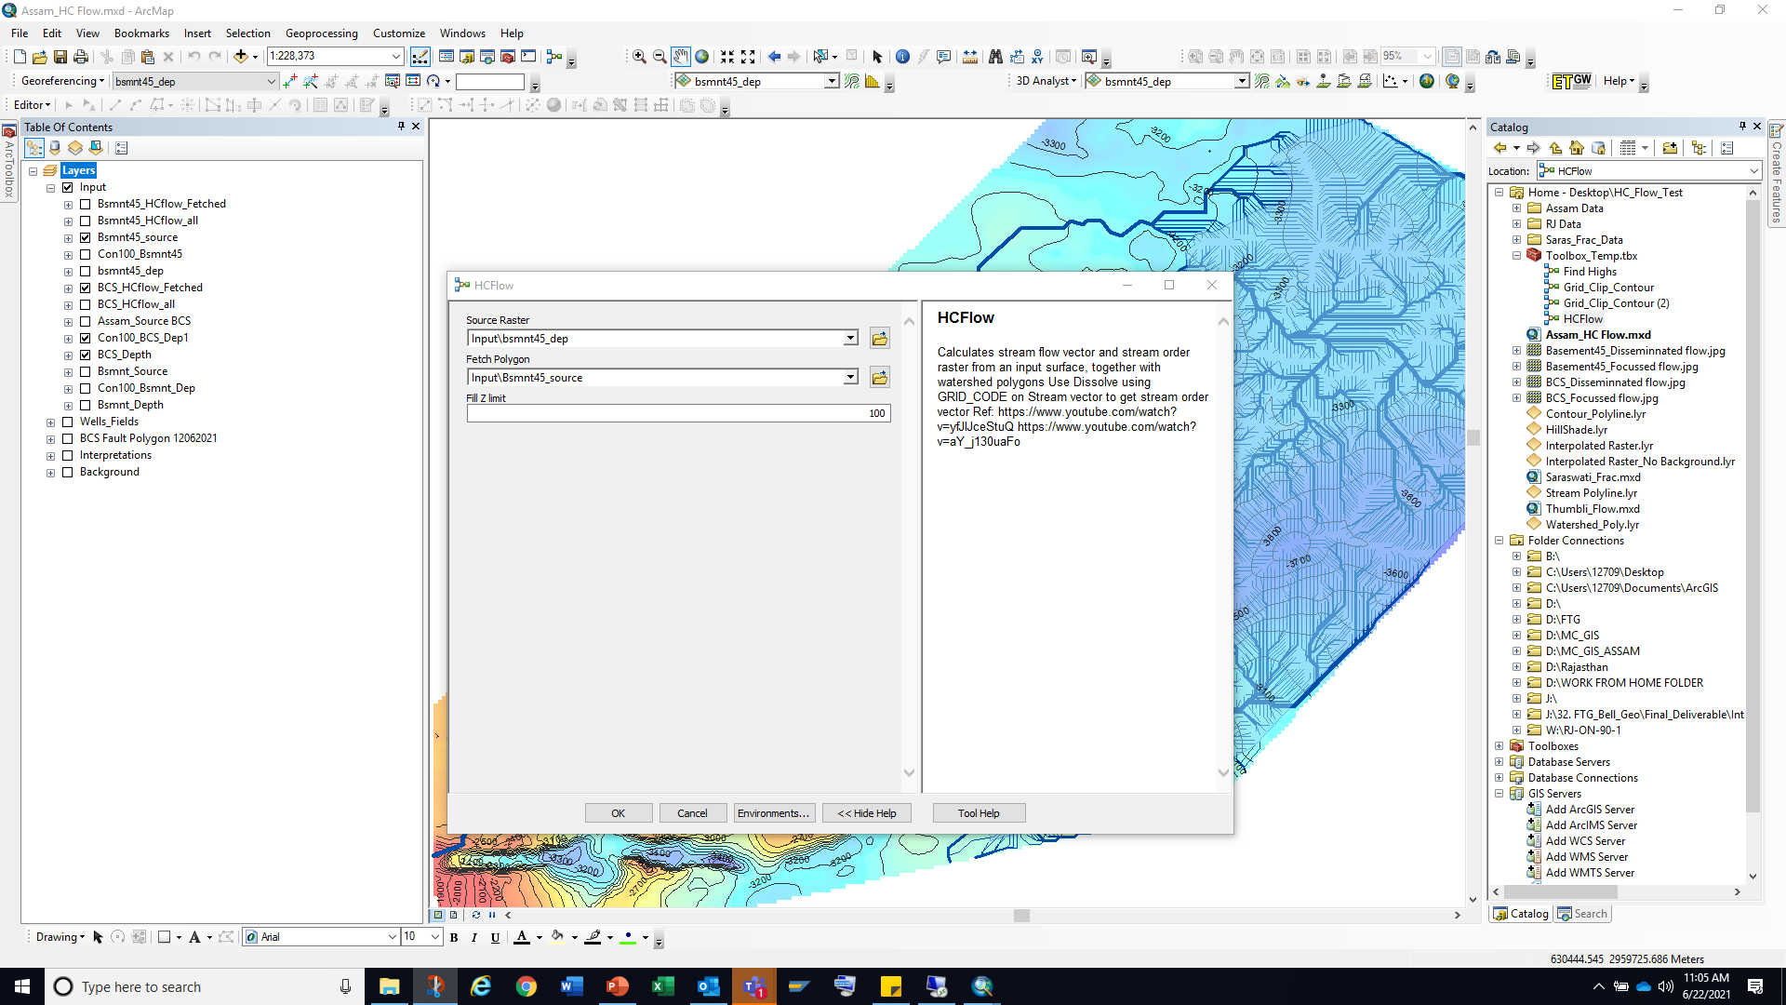

Figure . The models can be run as any other tool in ArcToolbox. The inputs are the parameters (marked by P) in the model. It is useful to include a short description of the model for easy understanding

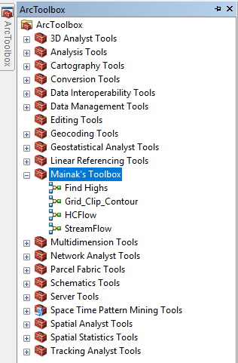

Figure . The models can be shared as tools in a custom ArcToolbox

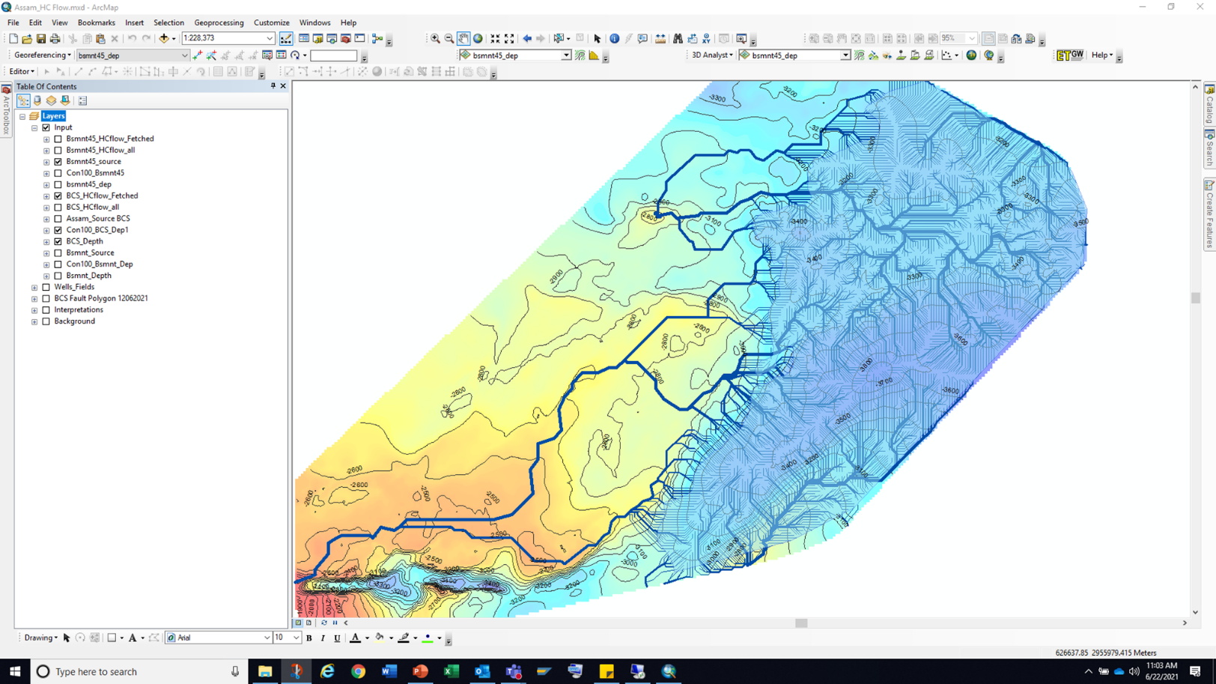

Figure . Upward flow of hydrocarbon map along the given surface from a fetch area in the eastern part, marked in blue